Steven Kim

Mr. Mason

ADV Cisco CCNP P 1, 2

12/15/13

Lab 5: AAA

**Purpose**

The purpose of this lab was to learn how to set up a RADIUS server and to enhance security to a further degree using the server. Learning AAA that was incorporated in this process was crucial: we had to learn how to identify which features of the server displayed each part of AAA.

**Background Information on lab concepts**

AAA: A type of security used by network engineers to manage control over which users have access to the server. The two main AAA protocols are the RADIUS protocol and the Diameter protocol.

Remote Authentication Dial In User Service (RADIUS) protocol: A protocol that manages AAA. Its primary purpose in enterprises is controlling access to a variety of networks. It uses UDP as its main protocol.

Diameter protocol: An enhanced version of the RADIUS protocol. It provides a safer transportation path by using TCP or SCTP (IP protocols that deliver data in an organized way) which uses the three-way handshake, rather than the UDP (IP protocol that sends data without requiring the establishment of any special paths) only has a one-way handshake that gained speed with the cost of the lack of accuracy. For security purposes, TCP is much safer than UDP.

Authentication: The process in which a user’s credentials or identity is authenticated. Through this process, users are attributed to a certain identity that helps the server identify the user; similar to contacts on phones, the server recognizes the identity that has been assigned to a user. Common examples of authentication include passwords, one-time tokens (OTP) which provides a single valid password per login, and phone numbers.

Authorization: The function of the server that determines which users are granted access. Authorization is a ‘guest pass’ that one needs to pass the router; it makes sure that no malicious hosts can trespass the router. Authorization filters users and determines which hosts have ‘passes’ to the server or router. Examples include control through bandwidth, IP addresses, and encryption.

Accounting: The process in which the server keeps track of users’ information. This feature of AAA keeps track of failures and successes of all login attempts. It is simply a ‘progress report’ that allows gathers all information regarding the status of the server. Accounting helps the router recognize which part has failed the most and collect data. Examples include analysis of capacity and trends of users and that of costs.

**Windows Server Features**

AD-DS: Also known as Active Directory Domain Services, this feature of Windows Server organizes network information into a hierarchical structure. This structure consists of a forest, domains in forests and organizational units in each domain. Literally taken from its name, the forest, which encompasses the entire network, provides a vast area of security. Additional domains are parts of the forest and provide a pathway for globally. OUs allow an easy delegation of the central authority of the owner to its users; this is similar to a computer system’s enabling of a CEO to delegate tasks more efficiently to his/her subordinates more efficiently.

DNS: Also known as Domain Name Service, DNS is a naming system that translates domain names to IP addresses. It allows a more efficient locating of hosts. Usually, this service in Windows Server is responsible for deliver detailed data and communication between the server and the host.

NAP: Also known as Network Access Protection, this feature of Windows Server allows the administrator to identify which parts of the network the user belongs to. NAP is responsible for increasing the level of access of users.

**Lab Summary**

To install Windows Server 2012 and use AAA to enhance security of my network, I began to install VMware, a software that allows virtualization of a server without an additional operational system.  
 As I moved on, I set the administrative username and password that allowed me to log in to this configuration of the server. Whenever I logged out, a password had to be entered to log in to the configuration mode of the server.

I followed the following steps to set up my server:

1. Prepare VMware and an iso file required for installing Windows Server 2012.
2. Before setting up the server itself, the network adaptor MUST BE CHANGED to Bridged mode.
3. Set administrator username and password to login when having to leave the server.
4. Follow the deployment configuration by clicking the flag icon next to the Manage tab.
5. Configure the Router so that it runs AAA.
6. Add Roles and Features for AD DS, DNS, and NAP.
7. Go to the Active Domain Directory Administrative Center and create a new User and a Group. Make sure that the User is a part of the Group that has been created.
8. Right click the server in the NAP tab and access NPS.
9. Click the NAP tab and enter NPS configuration mode.
10. Set up a Client Friendly Name and make sure that the user is a member of the group.

**Lab Commands**

Although the lap topology was simple, several commands had to be issued to enable AAA in the router and set up the RADIUS server:

|  |  |
| --- | --- |
| Router (config)# aaa new-model | Allows AAA on the Router |
| Router (config)# aaa group server radius [group name] | Sets up the RADIUS server with the given name |
| Router (config-sg-radius)# aaa authentication login default group radius | Allows group radius to login. |
| Router (config)#ip domain name [domain name] | Establishes domain name. |
| Router (config)# radius server [ip address of server] | Allows the user to enter the server mode. |
| Router (config-radius-server)# address ipv4 [ip address of server] | Allows the assigning of the ipv4 address of the server. |
| Router (config)# line vty 0 4 | Allows the user to enter the line mode. |
| Router (config-line)# login authentication default | Establishes authentication on the router. |

**Network Diagram with IP’s**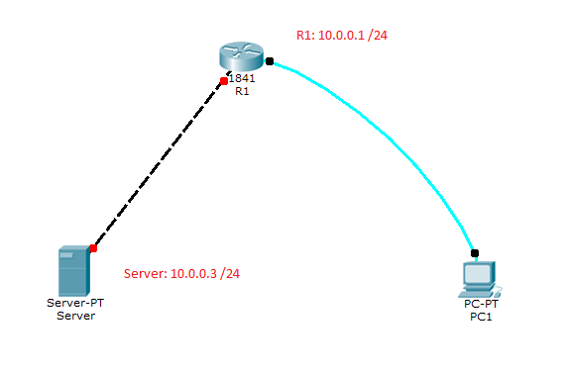

**Configurations**

R1 Configuration

R1#sh run  
!  
hostname R1  
!  
boot-start-marker  
boot-end-marker  
!  
!  
!  
aaa new-model  
!  
!  
aaa group server radius Steven  
!  
aaa authentication login default group radius  
!  
!  
!  
!  
aaa session-id common  
memory-size iomem 10  
!  
!  
!  
ip domain name CCnP12.com  
ip cef  
no ipv6 cef  
!  
multilink bundle-name authenticated  
!  
!  
!  
!  
license udi pid CISCO2901/K9 sn FTX1520806J  
!  
!  
!  
redundancy

!  
!  
!  
interface Embedded-Service-Engine0/0  
 no ip address  
 shutdown  
!  
interface GigabitEthernet0/0  
 ip address 10.0.0.1 255.255.255.0  
 no shutdown  
 duplex auto  
 speed auto  
!  
interface GigabitEthernet0/1/0  
 no ip address  
 shutdown  
 duplex auto  
 speed auto  
!  
!  
ip forward-protocol nd  
!  
no ip http server  
no ip http secure-server  
!  
!  
!  
!  
!  
radius server 10.0.0.3  
 address ipv4 10.0.0.3 auth-port 1645 acct-port 1646  
!  
!  
!  
control-plane  
!  
!  
!  
line con 0  
line aux 0  
line 2  
 no activation-character  
 no exec  
 transport preferred none  
 transport input all  
 transport output lat pad telnet rlogin lapb-ta mop udptn v120 ssh  
 stopbits 1  
line vty 0 4  
 transport input all  
!  
scheduler allocate 20000 1000  
!  
end

The following are the steps that are required setting up a Windows 2012 Server:

**Steps for Installing the Forest**

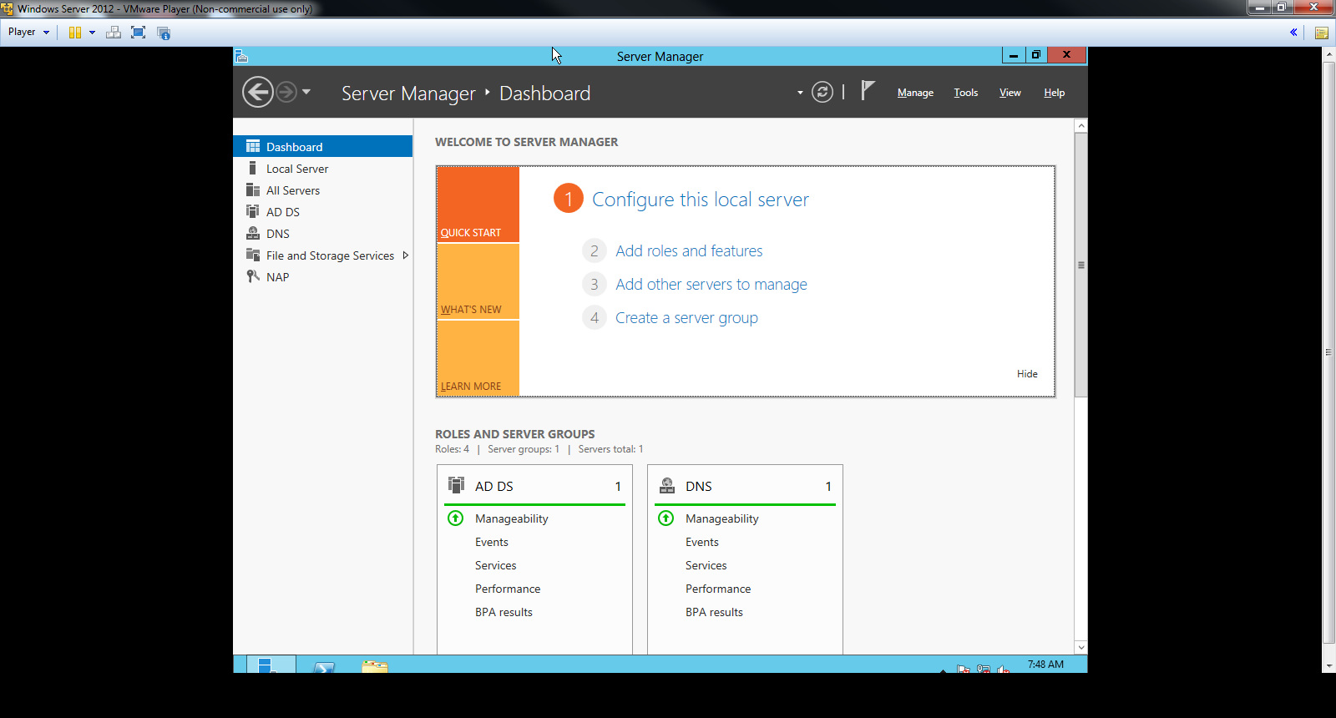 Once initial setup is complete, go to the Dashboard (default menu).

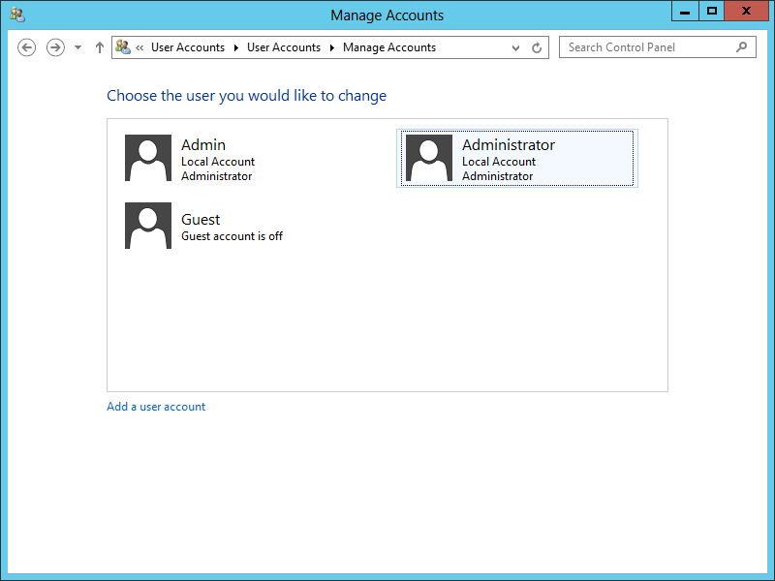

Set up the Administrator password for logging in to Windows Server 2012.

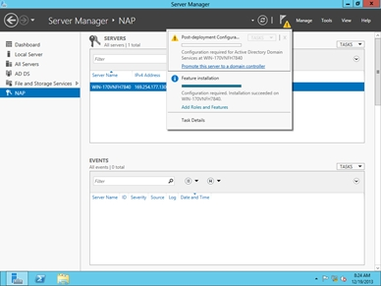

Click the flag icon next to the Manage tab and then Post-deployment Configuration

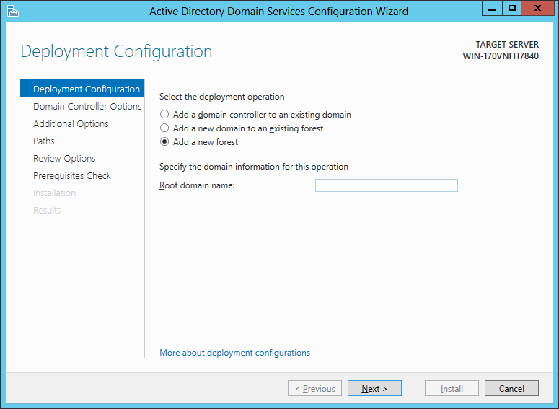

Enter the domain name for the first deployment configuration.

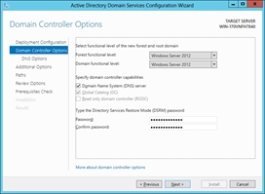

Click Next. Enter the password for Directory Services Restore Mode.

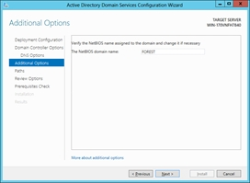

Click Next. Enter the NetBIOS domain name.

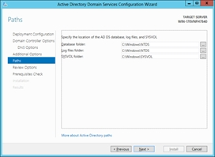

Proceed with the default configuration for the remaining three tabs.

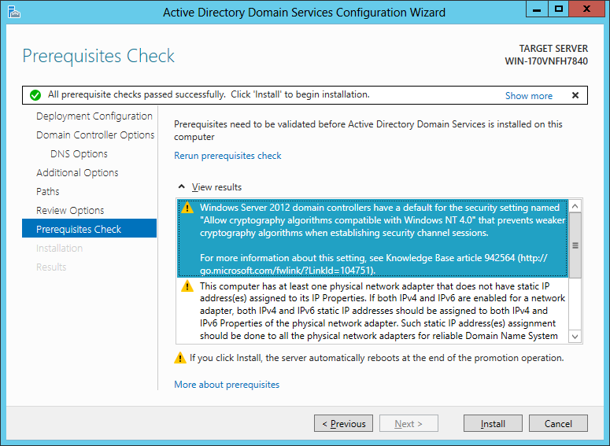

Click Prerequisites Check, then Install. Make sure that the prerequisites (steps above) are done before clicking Install.

**Adding Roles for All Features of Windows Server 2012**

The next step after the intial setup is to add roles for every feature of Windows Server 2012. The following is an example done by the DNS tab.

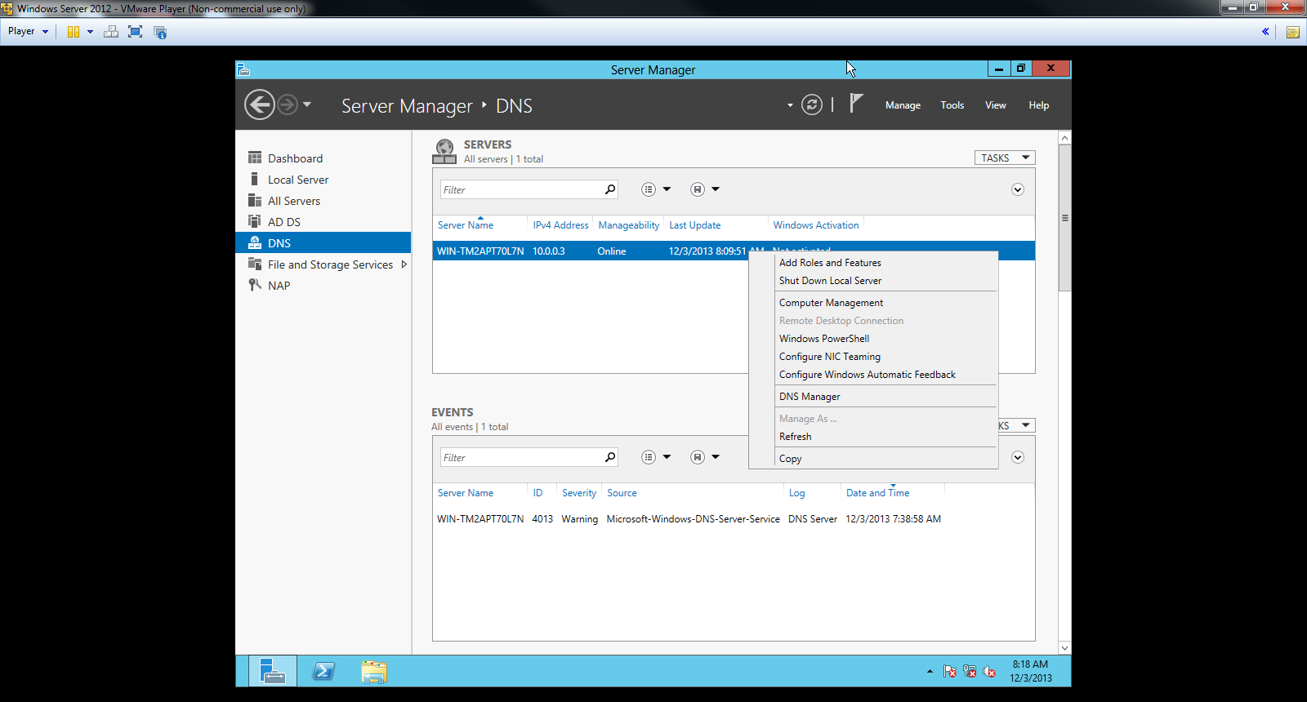

Begin the next step by right clicking on the server. Click Add Roles and Features.

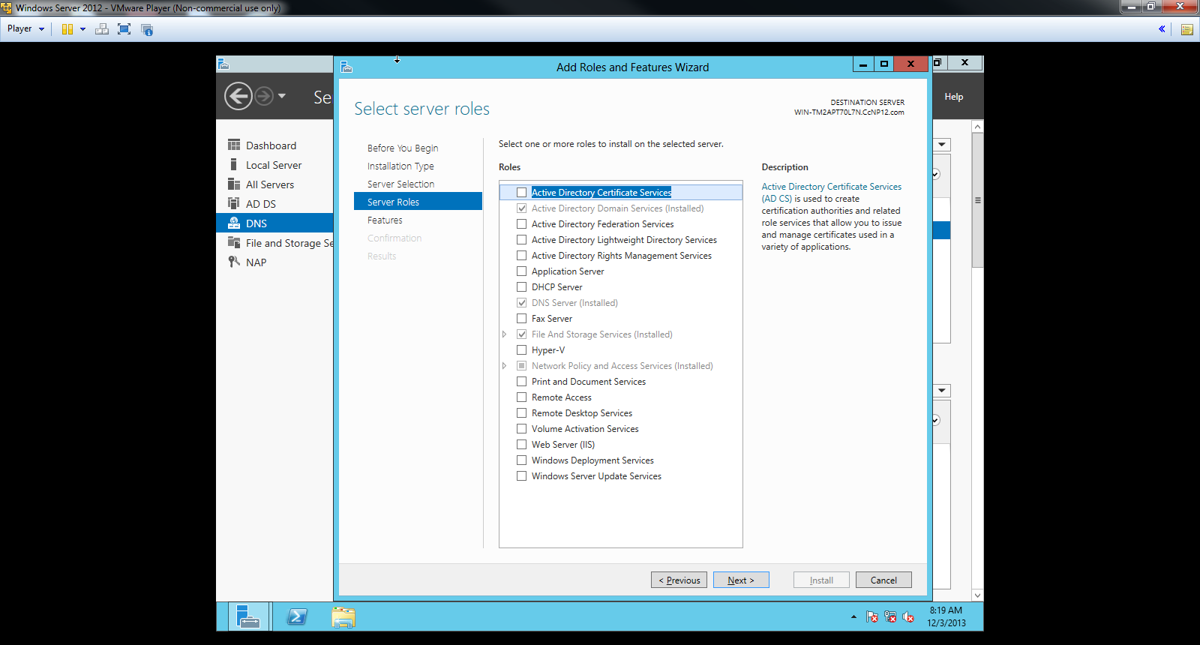

Click Next with the default settings for the first three tabs: Before You begin, Installation Type, and Server Selection. On Server Roles, check the boxes above and click next.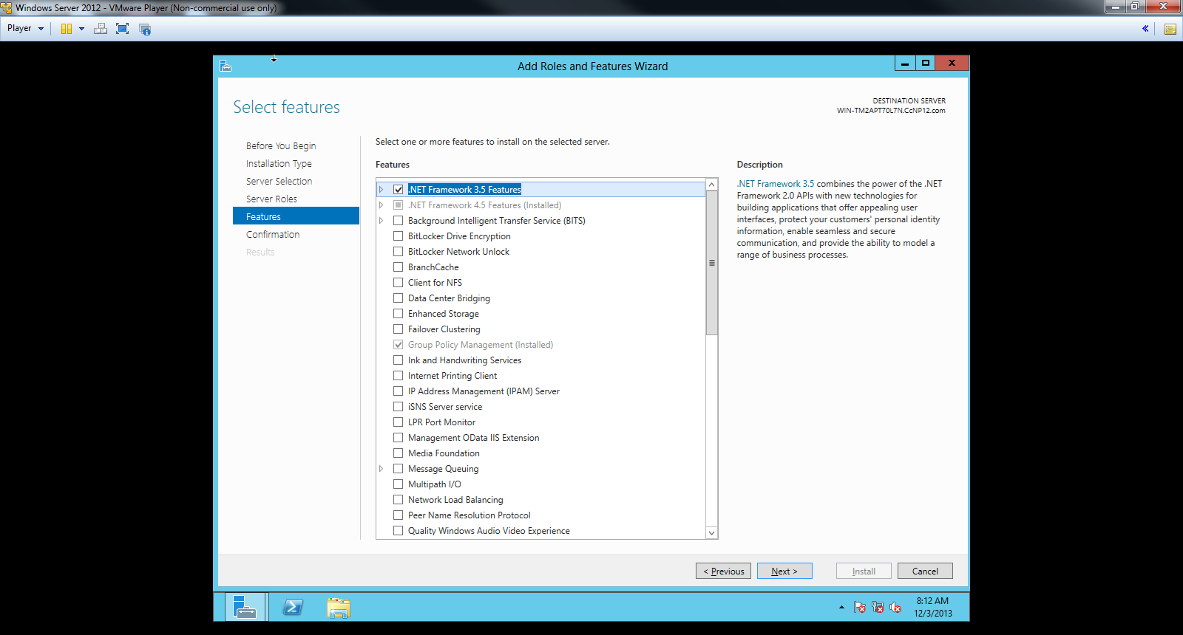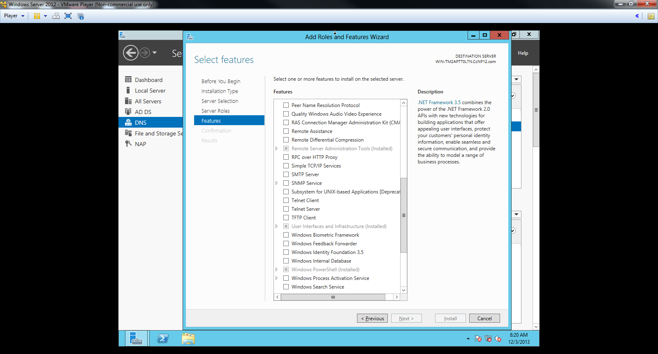

Check the boxes that are marked above and click Install.

It is crucial that these steps be followed for all three features: AD DS, DNS, and NAP.

**Setting up the User in the Active Directory Administrative Center**

The following steps will show how to create a new User and a Group.

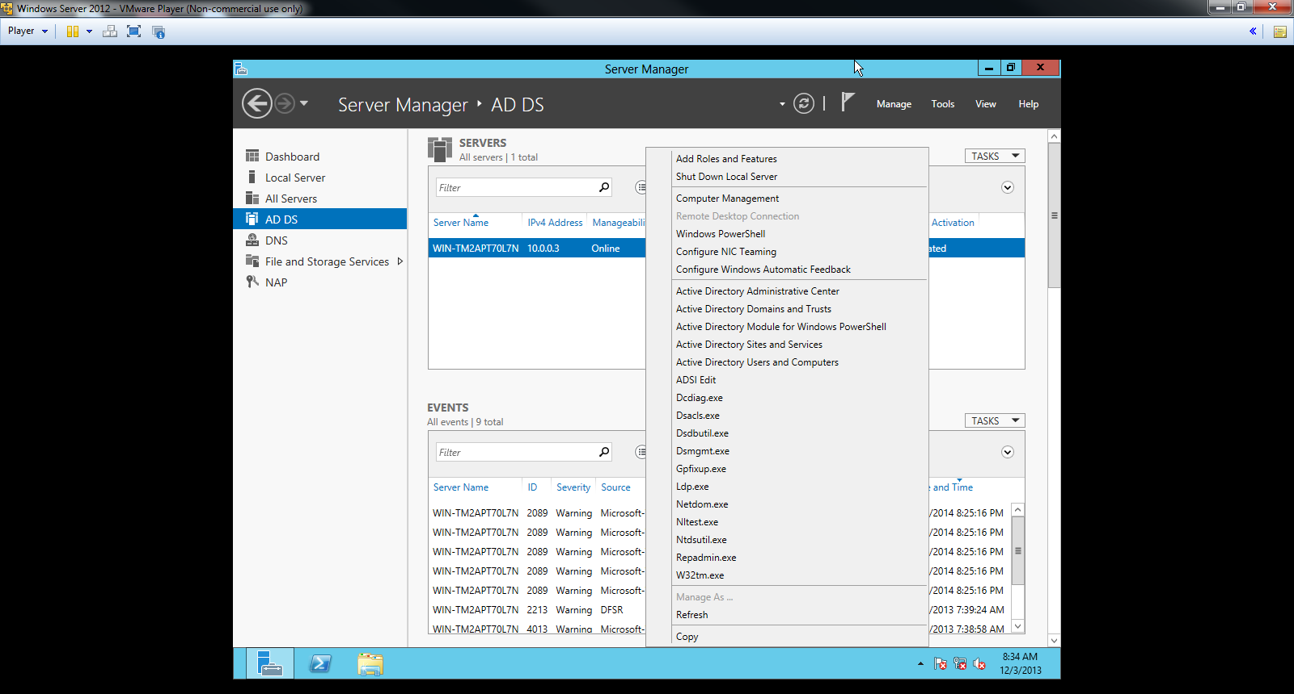

Click the AD DS Tab on the left side of the screen and right click the server.

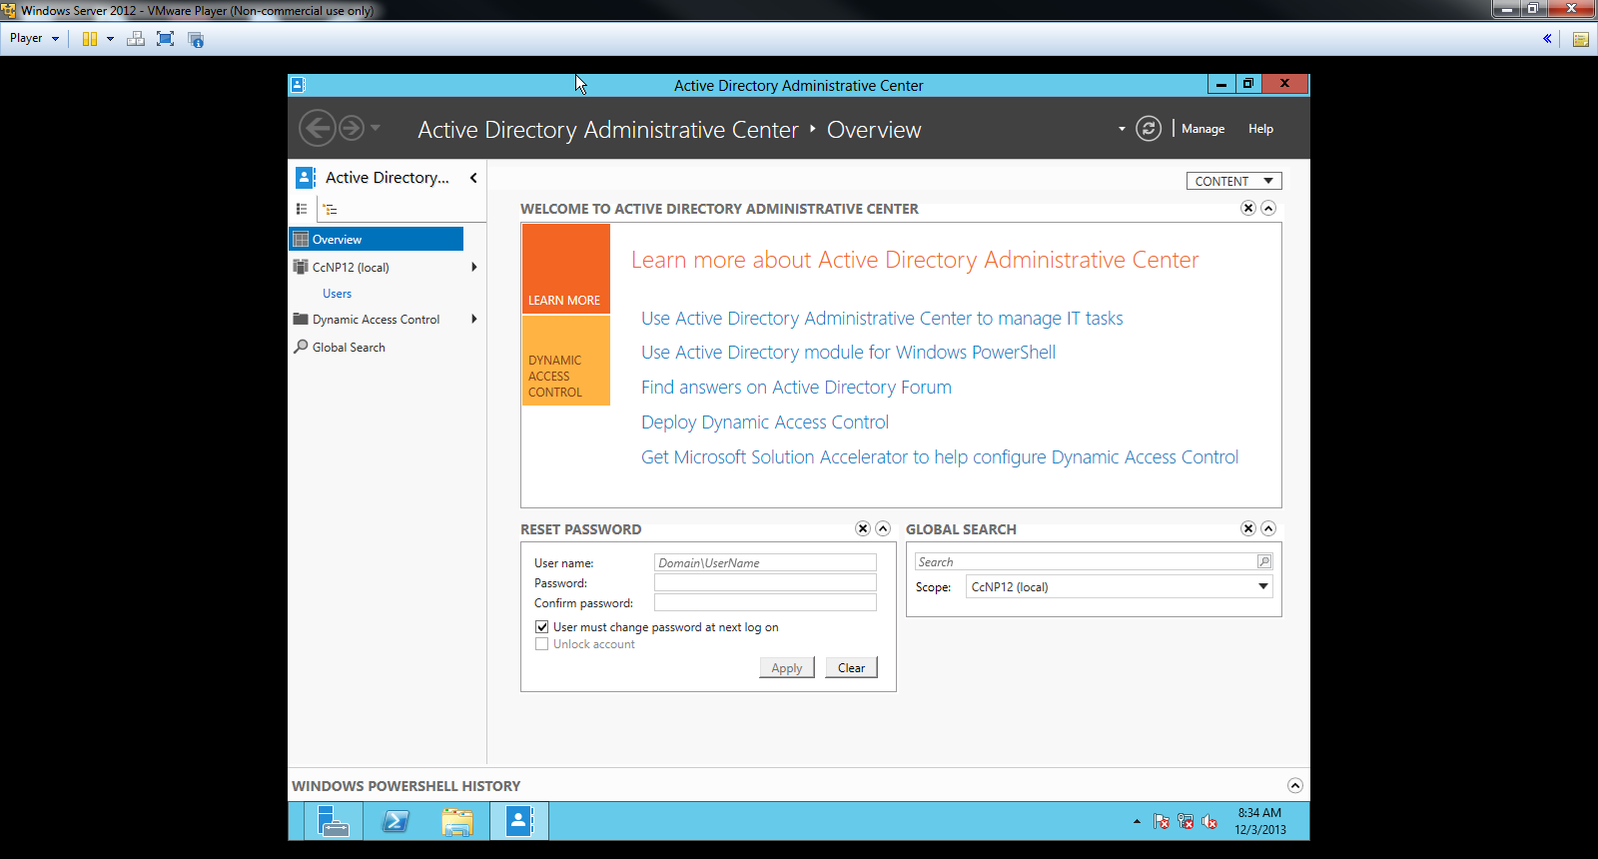

Click Active Directory Administrative Center. Above is the screen that should appear.

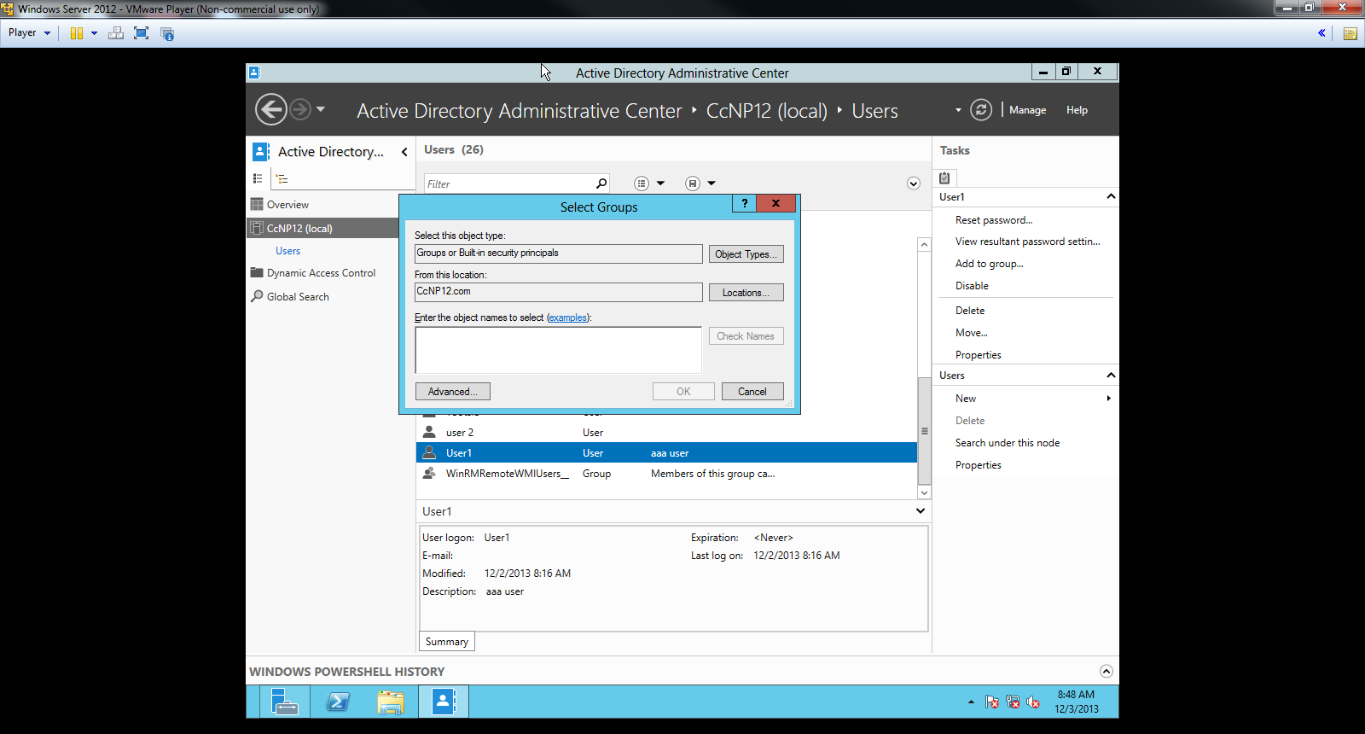

Click CCnP (the domain name excluding .com at the end) and create a server group. All information except the name may be left as default. Then, add a new user (User 1) and assign the new User to the group that was created.

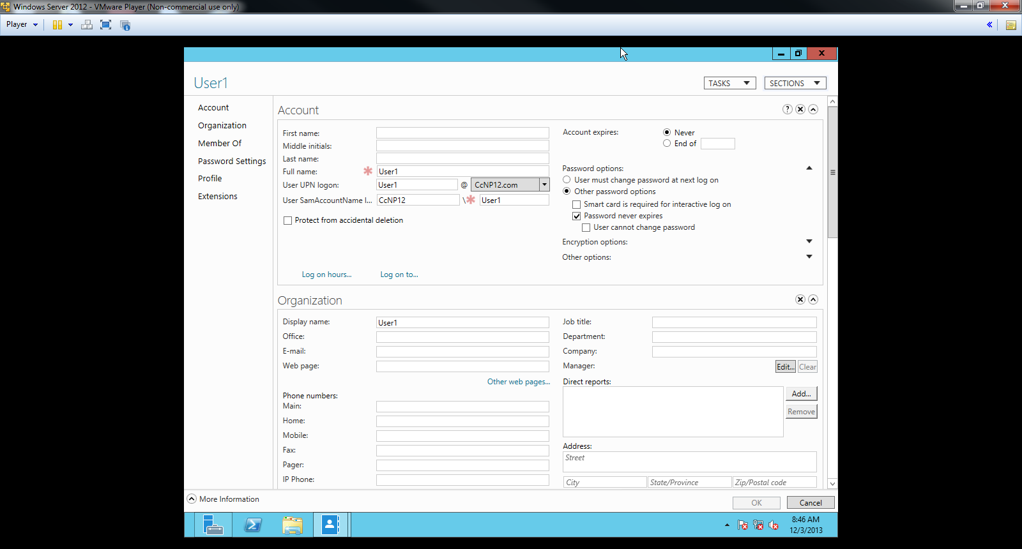

Right click the user (User 1 in this case) and fill in its Full name, User UPN logon, and User SamAccount name, as shown above. The domain name should be set by default. Below Password Options, set the password option of preference.

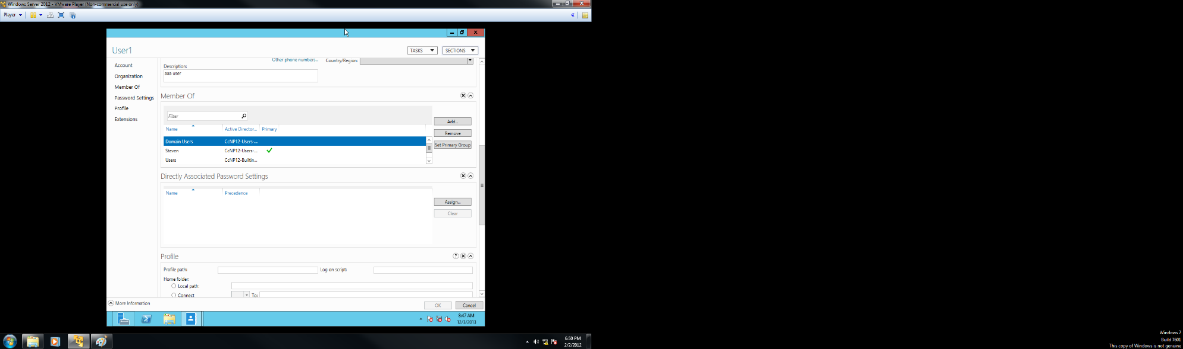

Below Member Of, verify that the user has been added to the proper group. This is the final step that completes the setup for AD DS.

**Setting up Network Policy Server (NPS)**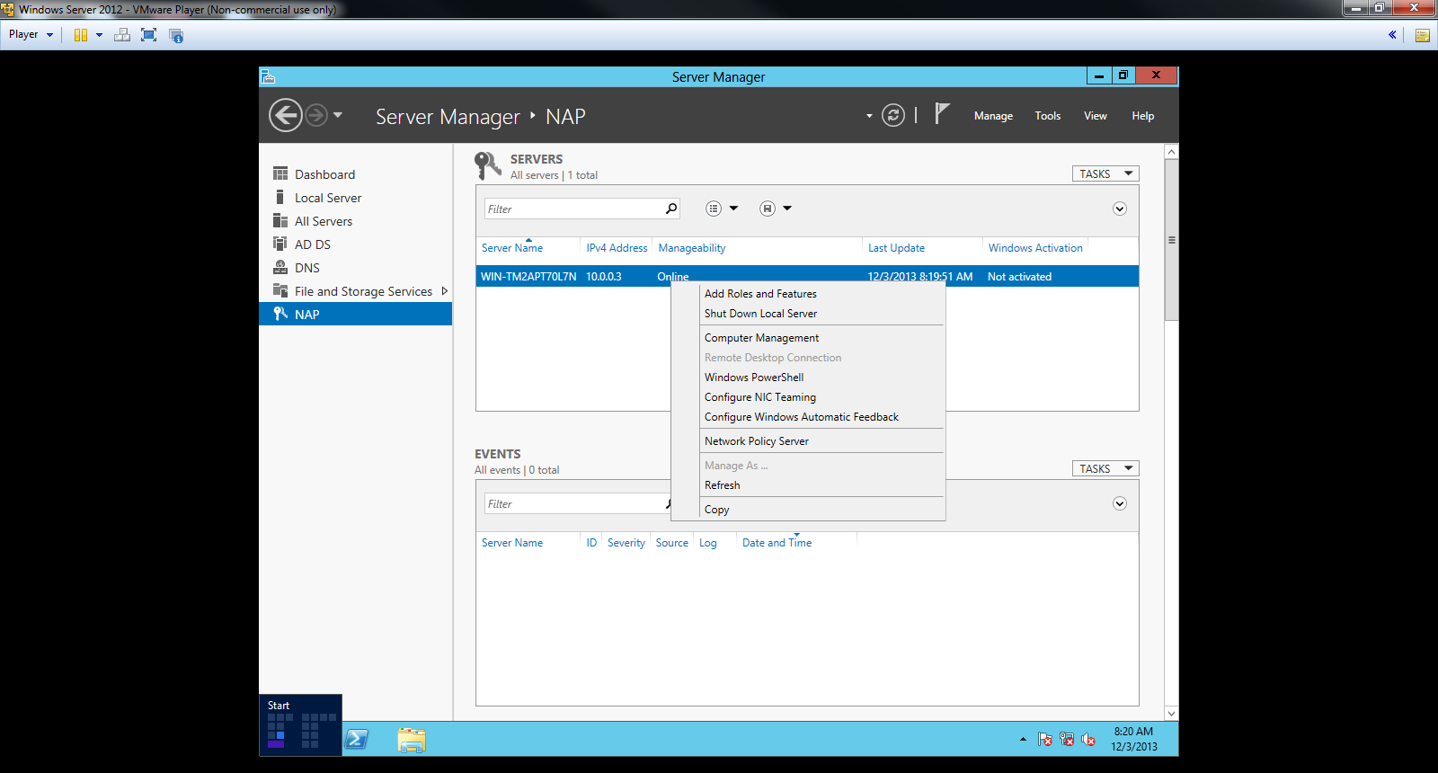

Click NAP and right click the server. Click Network Policy Server to enter NPS.

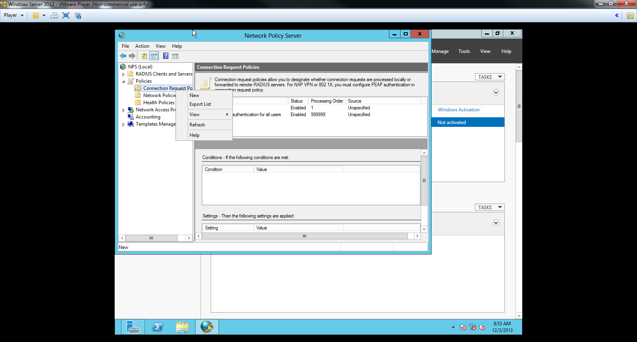

Click Policies to view the three tabs: Connection Request Policies, Network Policies, and Health Policies. Right-click Connection Request Policies and click New.

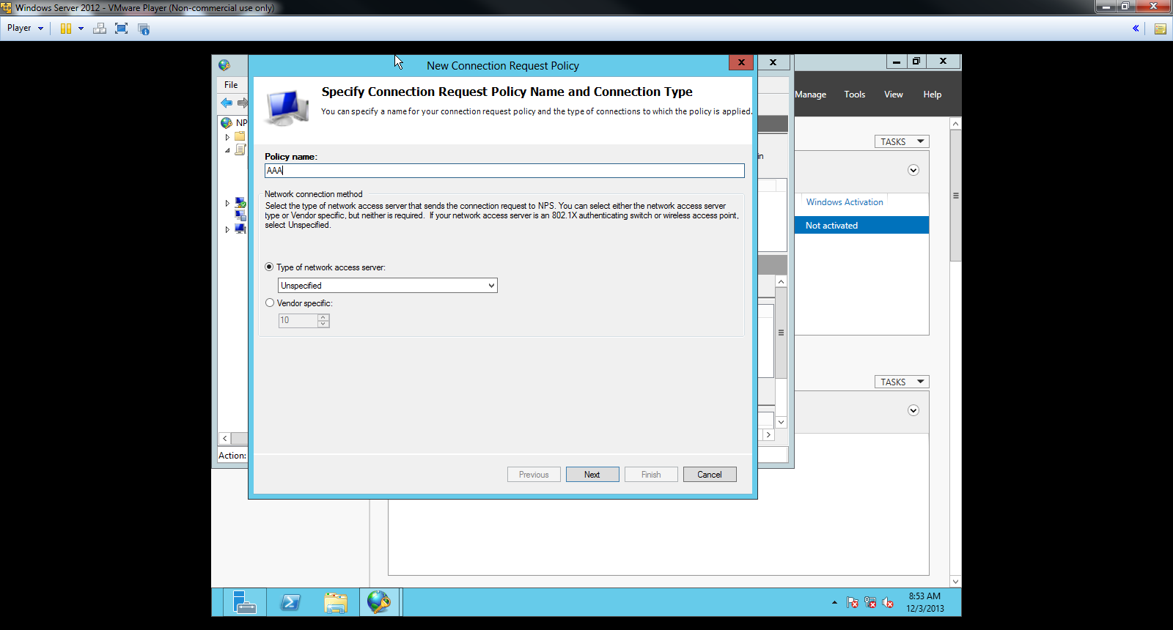

Above is the screen that should appear. Type in the Policy name and click Next.

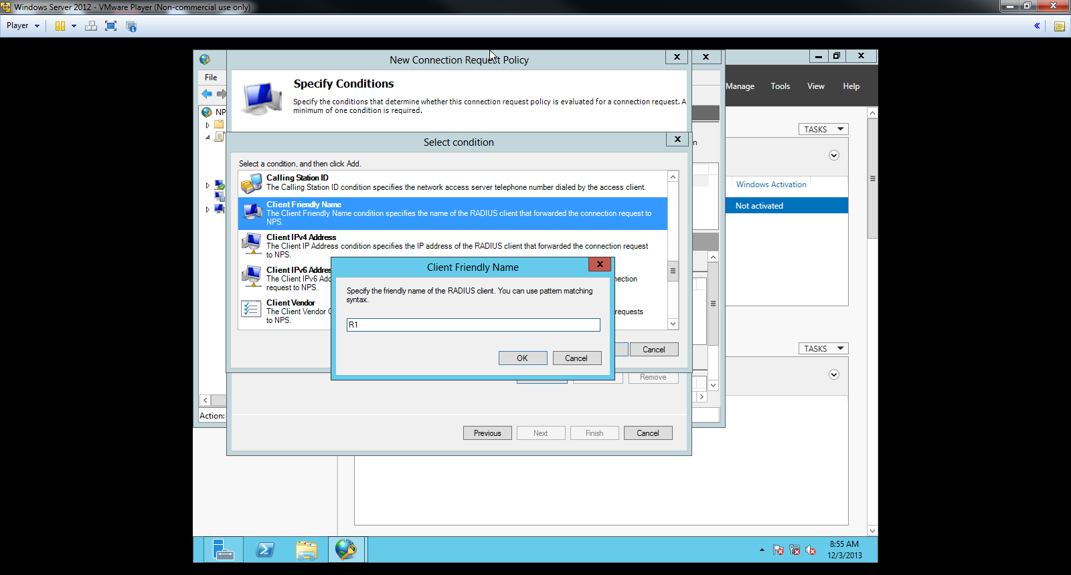

Click Client Friendly Name and enter in the friendly name of the RADIUS Client (the Router).

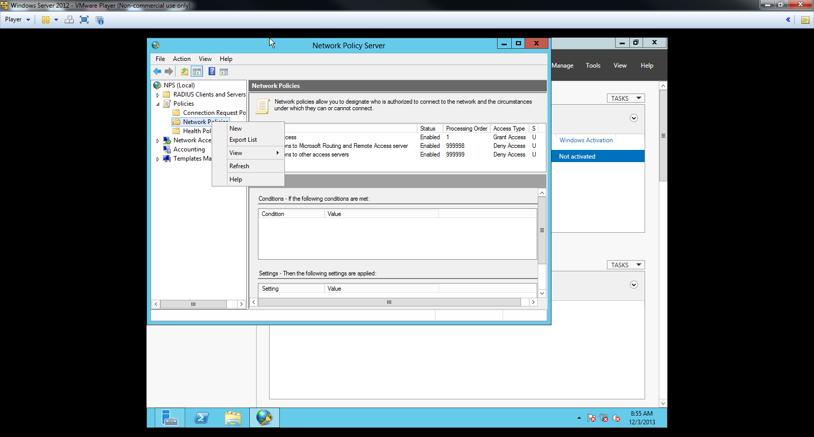

A line with a Processing Order of 1 should appear. Right click Network Policies and click New.

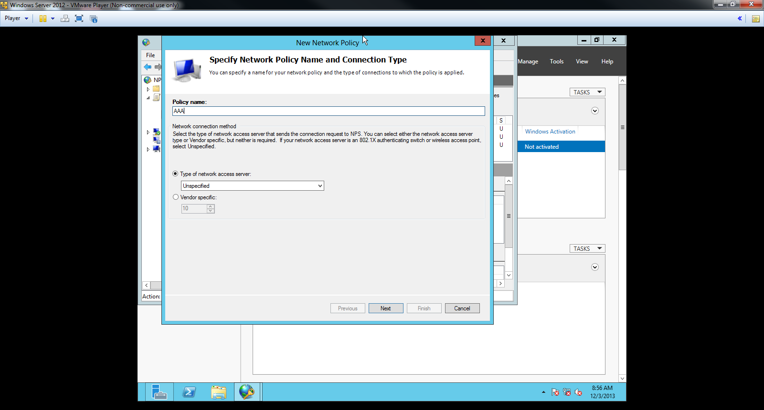

Type in the Policy name and click Next.

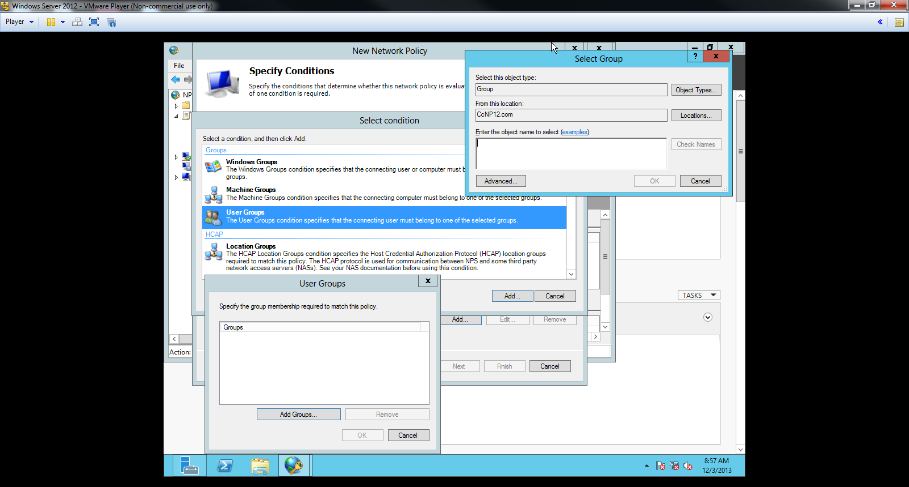

Select User Groups and enter the Group name. Click check names to verify that the server group can be selected. Click Add Groups and then Ok.

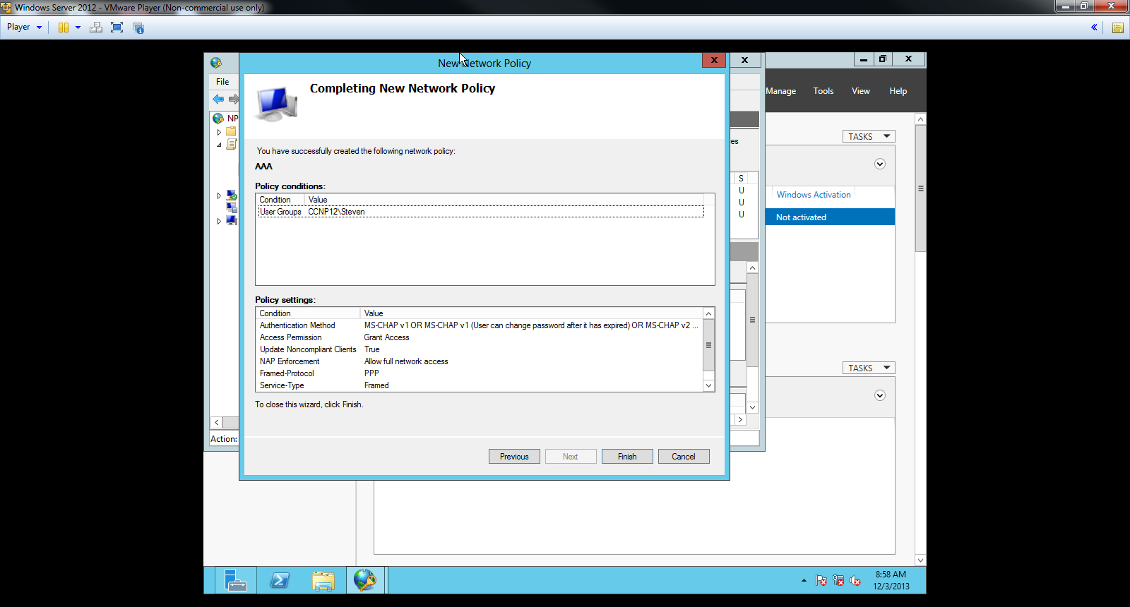

The screen above should appear. Verify the name of the User group, select it, and click Finish.

**Problems**

Learning how to set ups servers was especially difficult in this lab. I was not familiar with the concept of a server; Windows Server 2012 was a program that I had not managed before. Therefore, in order to efficiently set up a server, ample research was necessary. I had to research every feature of Windows Server 2012 to figure out which part of the configurations was necessary for setting up a server. Setting up server roles especially hindered me from doing my lab since I did not know what each server role were. I did not know what features such as “Network Framework 3.5 Features” did. With numerous trials and errors, I could finally figure out which features were necessary for server roles.  
 The steps that were necessary to setting up a server had to be followed with carefulness and in order. An error message appeared whenever I incorrectly followed a step or put the comments in different order. For instance, I did not realize that setting up the forest had to be the initial step before creating groups; therefore, I went to the AD-DS again and had to reinstall the forest with the exact necessary procedure. Some steps were completely out of order: I did not create a server group in Active Directory Domain Services and thus could not find the group in NPS.

**Conclusion**

Overall, I managed to set up a Windows server that could control users and protect the network with AAA. Although I had some troubles figuring out which part of Server roles were necessary for server installation, I overcame my difficulties with a sufficient amount of research and preparation. Unlike a CCNA student who barely knows how to even use a server, I managed to set up a Windows Server, figure out each and every part of the features of a Server, and acquire knowledge of how to use a server to grant and deny access to users depending on the situation.